Candy Project Examples
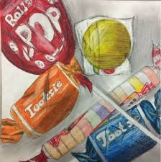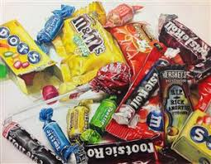
Solid drawing but too much negative space Exploded view of multiple aspects of candy
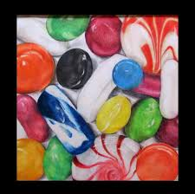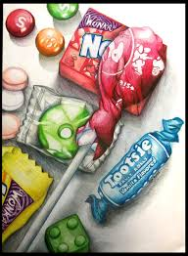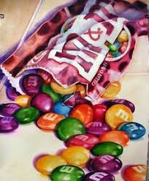
Great view of unwrapped hard candy Great view of overlapping and shadows Great view of an open bag with wrinkles
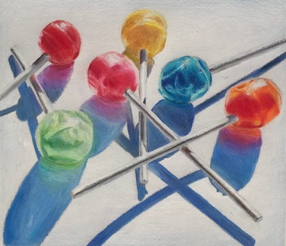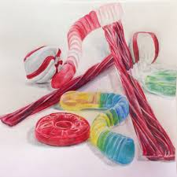
Too much negative space but excellent usage of drop shadows Excellent perspective and size proportions and drop shadows

