Flat Shape Breakdown within an Object
Isolated Color Masses Create the Image

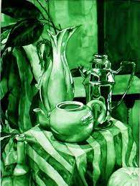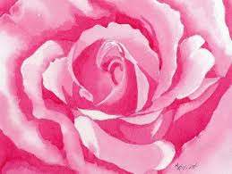
Note: these colors are all in the same color family, they do not jump to other color schemes outside of this one realm.
Analogous Color Schemes With Flat Shape

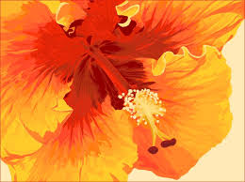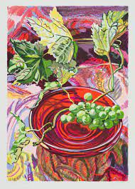

Note: Each color change stands alone, but side by side they all create a visual flow of seamless color transition. You will break down each color change as if you were creating a “coloring book” so it then becomes a “color by number puzzle” that is easily handled.

